Computer Language Coding Concepts

System Command Call with Argument
Basic System Command Calls showed the basic system command call notation, but most system command calls are incomplete without an argument.

System commands can use a simplified argument notation.

Explicit notation of an argument of a command:

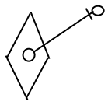

Can be simplified for arguments of system commands:

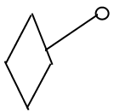

The simplified notation is only used for system commands, because system commands are so fundamental that they need a notation that is as simple as possible.

The general use of this notation will be explained with Object Get as an example. You probably will never use this notation for Object Get, but it is easier to explain this way.

Here is the basic notation of an Object Get system command:

Object Get
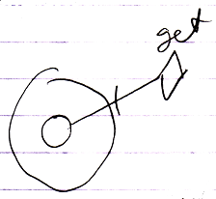

The Object Get command has a return value: the object. The object is an output argument. It is not displayed in the picture above, but it should be there to transfer it to another object symbol. This is drawn out as follows, using the simplified argument notation for system commands:

Object Get
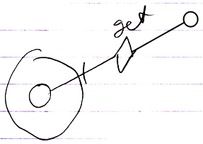

Now the output argument of the Object Get call is filled in.
Object Get is called upon the smaller circle in the bottom-left corner.
But next, an Object Set is implicitly called upon the smaller circle in the top-right corner.
The diagram above implictly causes an Object Set to be executed upon the smaller circle in the top-right corner.

Something similar happens in case of an Object Set command. Here is the basic notation of an Object Set command call:

Object Set
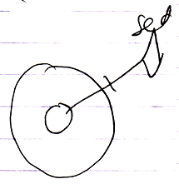

And here the argument of the Object Set command is filled in:

Object Set
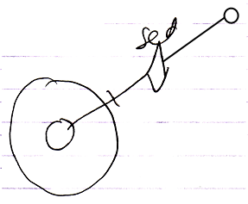

This causes an implicit Object Get on the smaller circle in the top-right corner, followed by the explicit Object Set, targeting the smaller circle in the bottom-left corner.

So the basic display of a basic system command call with an argument filled in implictly causes another system command to be called as well.

Below you will find an overview with all the system commands with their argument filled in using the simplified simplified argument notation for system commands. Which system commands are implicitly called, is also made clear in the overview.

Object Get | Object Set
Object Get ←  (Object Set →) | (Object Get →)  Object Set ←

Yielding over Class aspect:

Use As Class | Class Set
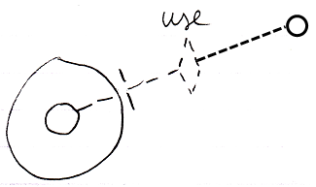 | 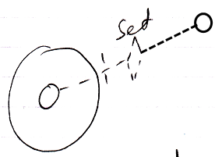
Use As Class ←  (Class Set →) | (Class Get →)  Class Set ←
Reference Class Get | Object Class Get
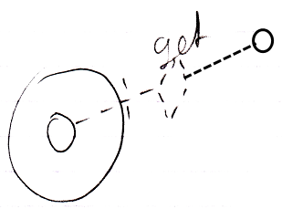 | 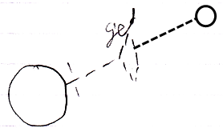
Reference Class Get ←  (Class Set →) | Object Class Get ←  (Class Set →)

Yielding over between Class aspect and Object aspect:

Class Set | Reference Class Get | Object Class Get
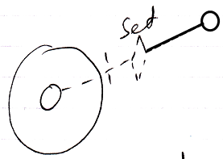 | 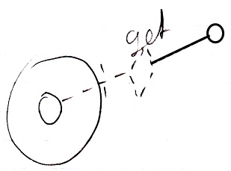 | 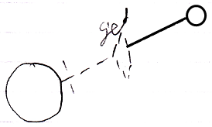
(Use As Class →)  Class Set ← | Reference Class Get ←  (Object Set →) | Object Class Get ←  (Object Set →)
Value Get | Value Set
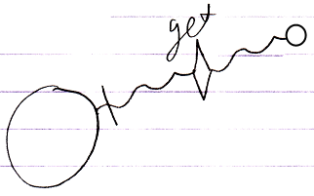 | 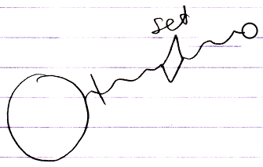
Value Get ←  (Value Set →) | (Value Get →)  Value Set ←
Clone (2) Get | Clone (2) Set
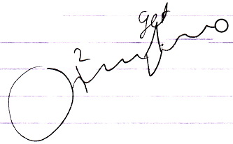 | 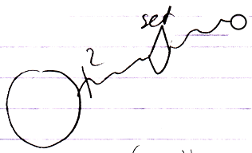
Clone (2) Get ←  (Clone (2) Set →) | (Clone (2) Get →)  Clone (2) Set ←
New
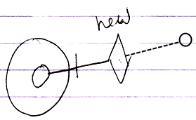
(Use As Class →)
New ←
Add
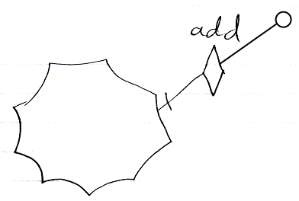
(Object Get →)
Add ←

Most of the notations above will never be used. Only the notation for the New and Add arguments are common.

But for executing Get, Use As and Set commands there are usually simpler notations: for instance the assignment notation. Only when a simpler notation does not suffice, a Get, Use As or Set command can be explicitly displayed. This basically only happens in cross-aspect assignments, that differ from the ordinary. In abstract diagram expression though, you can always use the explicit notations to simply make a point. When you look at the aspects introduced so far, the only time you might need the system command with argument notation for Get and Sets is in a Class Get – Class Set assignment. This creates the following notations of the different ways to use a class:

Class Assignment
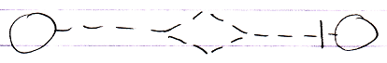
Use As Class ←
Class Set →
Class to Object Assignment
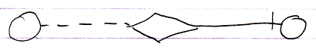
Class Get ←
Object Set →
Class Get – Class Set Assignment:
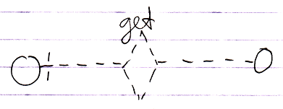
Class Get ←
(Class Set →)
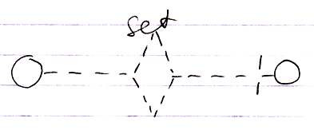
(Class Get ←)
Class Set →

The Class Get notation and the Class Set notation both have the same effect, only in one case it is the Get that is explicitly displayed and in the other case it is the Set that is explicitly displayed. It is not yet clear which is the best one.

See also: System Objects

Author & Copyright: Jan-Joost van Zon Date: July 24, 2009 – August 8, 2009 Location: Oosterhout, The Netherlands Status: Finished

